Your Name_______________________________________Date________________________
Phone Number ___________________________________
Before you request a mask, please read pages 1-4 and Section 1.0 of the Heidelberg SOP at
https://nrf.aux.eng.ufl.edu/_files/documents/41.pdf. It will help you decide what type of mask you need and explain how to generate your artwork.
Disclaimer: The NRF is not a mask shop but we do our best. Post processing measurements of critical features on the mask can be done but is time consuming and will require additional charges. We try very hard to hit target design sizes but there is no guaranteed spec. If you have a specific target line size spec, discuss it with staff before requesting the mask be made. The typical critical dimension tolerance for the 4mm and 4mmHQ write modes is +/-150nm. The spec for the 20mm write head is +/- 500nm. We purchase our masks ready for exposure from Nanofilm (website Nanofilm.com). The defect density of these masks is good but never perfect as is the case with most fabricated masks. If a defect occurs in the patterned area of a mask we will ask for your input regarding reworking the mask.

SUBMIT ONE FORM FOR EACH MASK.

- Check the mask type needed. See Mask Types (page 2) to determine the correct mask for your application. We are no longer stocking Quartz masks. If you need one you can order it and have it shipped to the RSC. Send email to walewis@ufl.edu for help ordering the correct mask from Nanofilm Inc.

☐5" soda lime glass, Cr $26.11
☐5" soda lime glass, FeO $49.50
☐4" mask blank – soda lime glass, Cr $19.42
☐4" mask blank – soda lime glass, FeO $42.29
- What is the smallest feature size in your mask design? __________
- What is the smallest space between features in your mask design? __________
- If you have features that are ≥5um but would like better than normal size accuracy, you may need to use 4mm or 4mmHQ mode. Consult with Bill Lewis if that may be the case. Otherwise 20mm mode will be used.
- What software will you use to create the design? _______________________
- GDSii is the easiest and preferred CAD format. “Layout Editor” can be downloaded and used for free and is preferred. “L-Edit” may also be used if your group owns the software. Layout Editor is available on the computer on the left 1st floor NW corner of the RSC building. AutoCAD may be used but it is discouraged. AutoCAD submitted file must be .DXF format and saved as “AutoCAD Release 12” version. DWG files are NOT compatible. If you intend to use AutoCAD to create your design, you must follow very specific rules for everything to go smoothly. Please read the section at the end of this form “AutoCAD Rules. Email your design file and this form to walewis@ufl.edu.
- The pattern printed on the mask must be mirrored in the X axis to appear as designed on the exposed sample if the mask is to be used on a mask aligner. This is because the sample is exposed with the mask, chrome side down with the mask flipped 180 degrees in the X axis. This can be done you or you can have RSC staff do it.
Do you want staff to X mirror your design mask? Yes ☐ No ☐

- For GDSII files only…..What is the GDSII file name? __________________. What is the “cell” or “structure” name (not the name of the layer) ? _______________________________.
- The 0,0 coordinate (i.e. center of your design) must be where you want the physical center of your mask. This can be done using the “Move” command in Layout Editor. Contact Bill if you need help with this. Initial here to acknowledge you understand ____________
- What layer numbers (not layer names) should be used to create THIS mask? ____________________________________________________________________________
Note: Boolean operations such as “OR, CUT, XOR” may be performed on layers during conversion i.e. layers may be subtracted or added together.

Note: Normally, the terms “Dark field and Light field” are used to describe the polarity of photomasks. We are NOT going to use those terms for this form since it seems to cause a lot of confusion and heartache.
- Mask Polarity_______ For help determining the correct polarity for your specific process, see “Mask Polarity” section in the Supplemental Information below.

Does the mask need to pass or block exposure light in the areas of your design artwork?
Check One……….
The Art work in your design should be “Clear/Glass” ☐ or “Chrome” ☐
NOTE: You do not need to be concerned with the polarity when you create a design. The polarity can be changed via the Heidelberg conversion software based on the answer to the question above.
- If you answered “Chrome” in question 11 complete this question. In the example pic below, the black areas will be clear glass on the mask. The red artwork will be chrome. For your design, how far out does the clear area of the mask need to extend past the furthest most artwork features top, bottom, left, right.
Enter distance in MM__________ (5-10mm is typical) Note: Keep the value low as safely possible since it will add to the Heidelberg exposure time.

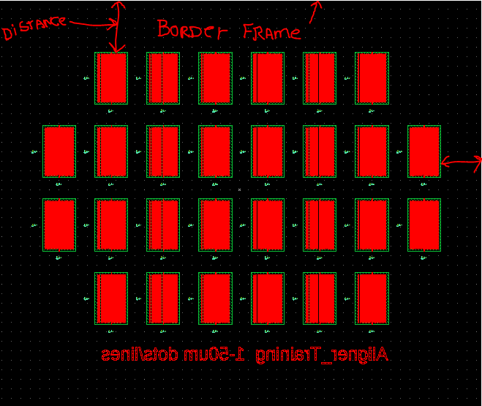

- Email your design file and this form to walewis@ufl.edu.
- You must also “Request Service” on the RSC website

Supplemental Information about making masks at the NRF

Mask Types
5” glass (sodalime), Cr - most commonly used at the NRF and needed for exposure of entire 4” wafer on NRF mask aligners. Minimum feature size (and space) is ≥2um. Compatible with both NRF mask aligners. Not compatible with Suss MJB3 Aligners used in labs outside of the NRF.
5” glass (sodalime), FeO – transparent to visible light making 2nd layer alignment much easier on the mask aligner. Minimum feature size (and space) is ≥3um
4” glass (sodalime), FeO – transparent to visible light making 2nd layer alignment much easier on the mask aligner. Normally not used unless you are exposing on a Suss MJB3 commonly found in labs outside the NRF. It can be used on the Suss MA6 aligner but NOT on the EVG-620 aligner.
4” glass (sodalime), Cr – normally not used unless you are exposing on a Suss MJB3 commonly found in labs outside the NRF. It can be used on the Suss MA6 aligner but NOT on the EVG-620 aligner.

Mask Polarity
The Heidelberg laser writer exposes the areas inside the artwork or polygons. These exposed areas are developed away and then etched away leaving clear glass. If no changes are made to your artwork design polarity all the areas within your artwork will be clear glass i.e. passing exposure light. If you need the artwork regions of your design to be Chrome/Iron Oxide, then your design will be inverted.
Examples:
Plasma or Wet Etch with positive liftoff (subtractive) = Artwork should be clear on mask
Liftoff Process using negative photoresist (PR) = Artwork should be chrome/iron oxide
Liftoff Process using image reversal of positive PR = Artwork should be chrome/iron oxide
Liftoff Process using LOR + positive PR = Artwork should be clear on mask

MASK COSTS ESTIMATES

Hourly rate for the tool
UF Internal $48
External Academic, Ext Affiliated $72
External $96

You can estimate the mask cost using the “Mask Cost Estimator” excel file. It can be downloaded from the Heidelberg web page on the web site, click “docs”.

Rules for Autocad

    - Save all files as “AutoCAD R12/LT2 DXF format. The conversion software may not support newer file versions. Note: .dwg files are NOT supported. Save the file as .dxf.
    - Do not open a .dxf file in a GDSII software such as “Layout Editor” or Ledit” and save it as a GDSII file. It usually does not work correctly. You may convert the file directly from Autocad (.dxf) using the Heidelberg Conversion software. Not advisable, but works if these rules are followed.
    - Always turn on “Snap to Grid” i.e. Grid Snapping in Autocad. The grid size should be set to 1.0 or 0.5 micron.
    - Turn on “units” and set to microns.
    - No self-intersecting polygons.
    - Always join polylines. The closing polygon point should have the same exact coordinate. Be especially cautious when using arcs within a polyline.
    - Only one font is provided with the dxf conversion package.The dxf standard font will replace any font selected in the DXF-design.
    - Only the following attributes assigned to a text are supported: ROTATION, MIRRORING, SCALING
    - Avoid placing structures in layer 0.
    - Do not use special characters in the layer names.
    - Try to design by means of the metric system.
    - Use millimeters (mm) as the standard unit (Some design programs will not accept inches!)
    - Polylines with widths must not have a change in its widths (tapered lines).
    - Various scaling in x and y when inserting a block is not supported.
    - External blocks are not supported.
    - Try to use only the following entities: CIRCLE, POLYLINE / LWPOLYLINE (with or without width), and TEXT.
    - Use a “grid snap” or “snap to grid” system when you design in Autocad. A good grid scale would 0.25, 0.5 or 1um.
    - Do not use “hatch” fill in Autocad.
    - No nested polygons i.e. a polygon within a polygon.
    - No Lines. Lines are not understood by direct write systems. Polygons only…
    - Email your file to walewis@ufl.edu.

