RSC User Daily Work Plan Form

This form must be submitted to rsc-dwp@mail.ufl.edu by 3 PM on the business day prior to the reservation date. The work plan must be reviewed and approved by RSC staff prior to access. Only users who have been given prior approval by RSC staff can submit a daily work plan, and the work can only be performed on projects that are approved by the UF VPR as critical or time sensitive. Bring samples in container for sanitation.

Please be on time for your tool/instrument reservation and be courteous with regards to reserving only the time needed to complete your work plan. The RSC staff will be disinfecting touch surfaces between user appointments. Entry and exit will be restricted to the west doors. Users must check out with RSC staff at the end of their tool/instrument session. If users must leave while analysis is in progress, notify staff when exiting and returning to the building; entry/exit will be minimized. Questions should be directed to rsc-dwp@mail.ufl.edu.

Contact Information:
*Only projects/funding sources approved by the UF VPR as critical or time sensitive will be allowed RSC access.

- Name: Click or tap here to enter text.
- Phone number: Click or tap here to enter text.
- PI name: Click or tap here to enter text. Project: Click or tap here to enter text.

Date/Time of Reservation(s):
*Multiple reservations are allowed if the tool(s) are available, only one form is required per day. Multiple reservations should be consecutive, entry and exit for users will be minimized. RSC staff will perform check in/check out for users.

- Tool reservation(s): ☐ Yes *No approval without reservation, unless not TUMI-controlled*
- Date for reservation(s): Click or tap to enter a date.
- Start/end time of reservation(s): Start/arrival: Click or tap here to enter text.
End/departure: Click or tap here to enter text.

Tool(s) and Room Number(s) for Reservation(s):
*All tool/instrument(s) and corresponding room number(s) must be listed for the day of access. If other room(s) plan to be accessed (e.g., adjoining room for materials or restrooms), please list and disclose at check out. Cleanroom access does NOT need to list room numbers. Tools not on the TUMI system can be listed but must have prior approval for access.

- Cleanroom: ☐ Yes ☐ No
- Tool/instrument(s): Click or tap here to enter text.
- Room number(s): Click or tap here to enter text.
- Consumable(s): ☐ Yes ☐ No Material(s): Click or tap here to enter text.

Hazardous Materials:
*Hazardous material use will be reviewed by staff for approval.

- Are hazardous materials needed? ☐ Yes ☐ No
- Hazardous material description: Click or tap here to enter text.
- Room number(s): Click or tap here to enter text.

FOR STAFF – LEAVE BLANK

Temperature check: ☐ Yes ☐ No
IN
OUT
Additional room(s): _________________________________________________________________________________
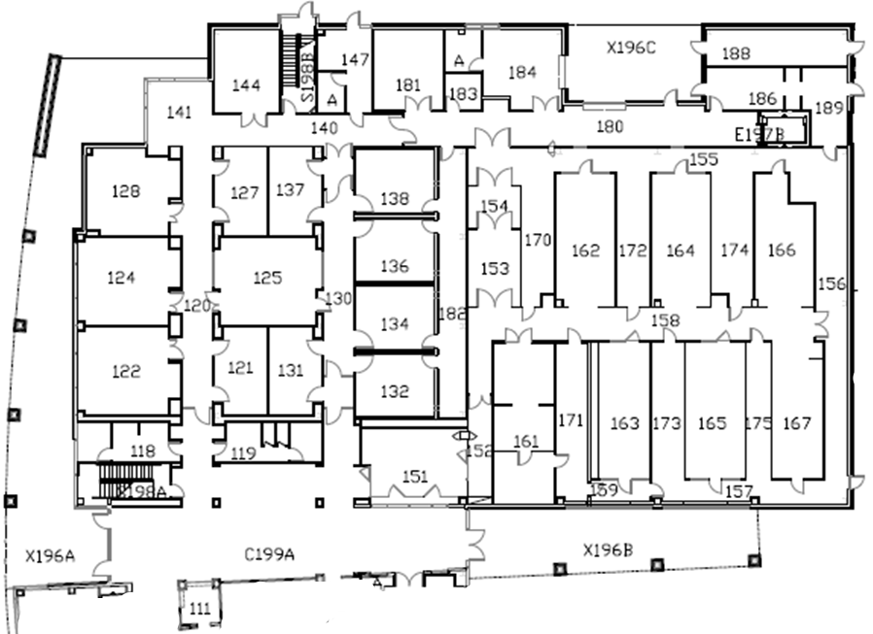

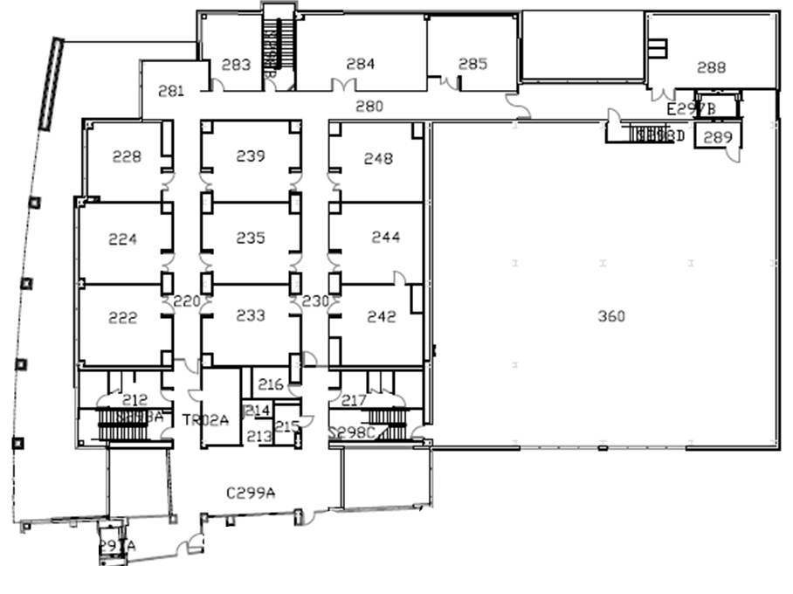

Additional Notes: __________________________________________________________________________________

