RSC Facilities - COVID-19 Related SOP

We appreciate all of our customers and want their research to proceed with minimal delays. We realize that we are a physical point of contact between many departments, colleges, and business units within the University of Florida. A COVID-19 case at the RSC is likely to have a broader impact than in an individual PI’s lab. Thus, we ask that you consider our entire research community as you follow these new procedures.
Notifications and updates to this document will be posted as needed.
Latest changes will be highlight in blue.
Approval for RSC activities is based on directives from the UF Vice President of Research. Confirmation of project approval by the VPR Office must be supplied to the RSC by the PI through the PI RSC Activity Resumption Approval Request Form along with submission to VPR, and HR approval to enter campus received by each user after the screening/testing has been completed. Email of HR approval to enter campus must be received before RSC access is approved.
General COVID 19 Guidelines for the NRF building
- All entrances to the RSC Building will remain locked.
- Face coverings must be worn inside the building at all times.
- Hand-washing/sanitizing is required as you enter and move from one space to another in the building.
- Use of gloves is encouraged to avoid cross contamination where needed.
- RSC staff will be monitoring and disinfecting laboratory touch surfaces (keyboards, mice, handles,..) after each user’s session. Instrument specific disinfecting procedures will be performed by RSC staff in the first stages and become available for users.
- RSC staff will perform hourly disinfecting of common area touch surfaces (door handles, stairwell handrails,…). Additionally, RSC staff will be conducting laboratory safety checks hourly.
- A CDC/EPA/FDA recommended disinfectant will be located in each user lab. Proper procedures will be provided.
- All meetings must occur virtually (e.g. via Zoom).
- Social distancing of at least 6 feet must be maintained both inside and outside of buildings.
- Students may only visit laboratories or the cleanroom. Student offices and bullpens are closed and will remain so for at least the summer.
- Anyone who has a fever or thinks that he/she might be ill may not enter the building. If symptoms develop while in the building, the individual must leave the building immediately, and arrange for testing through the UF Health Test and Trace initiative. A non-contact thermometer will be available upon request.
- No visitors or vested researchers are allowed in the RSC facilities until further notice.
- Violations to the safety protocols can result in suspension of access to the facilities.
- Anyone that enters the RSC facilities and has positive test results for COVID-19 should notify the RSC Director as soon as possible. If the individual that has tested positive was tested at UF, UF’s test and trace initiative would contact all areas and people the positive person encountered.

Procedure Sections
- Sample Drop Off and Pick Up
- Building Entry Procedure
- Protocols for Building Movement/Traffic
- Lab Procedure
- Reservations and TUMI Procedure
- Cleanroom Procedure
- Building Exit Procedure
Sample Drop Off and Pick Up
  - Sample Drop off Procedure
    - Fill out the “Sample Drop Off Form” located on the “Policies and Forms” page on the RSC website and submit via email to rscinfo@mail.ufl.edu.
    - A staff member will contact you by email and arrange a time for drop off.
    - A conference table is located outside of the front entrance for sample drop off.
    - Please wear a face covering during drop-off. Bring your sample in a Ziploc bag and place on the table. The sample drop off form will be enclosed in the bag with the samples, as well as any portable drive to be used for data storage. If the sample is dropped off without a portable drive, data can be shared via email or cloud-based storage service, such as Dropbox.
    - Call the staff member so that they may meet you outside the front entrance, use the standard 6 ft distance rule.
    - The staff member will wipe down the outside of the bag with a 70/30 2-propanol (IPA) solution.
    - Samples will be removed from the bag with clean gloves and the bag can be laid flat for a clean prep area.
    - Samples will be decontaminated with the process agreed on the “Sample Drop Off” form (UV, 70/30 IPA, or 72 hr. isolation).

  - Sample Pick Up Procedure
    - When the analysis/fabrication is complete, the staff member will place the sample and portable drive back in the Ziploc bag using clean gloves and wipe down the outside of the bag with a 70/30 IPA solution.
    - Staff will contact the customer via email to arrange a pickup time. Please wear a face covering during the exchange.
    - At the arranged time, the staff member will meet the customer outside the front entrance and place the sample bag on one end of the table using standard 6ft distance.
    - The customer can now approach the table and take the whole sample bag with them.
    - If the sample is dropped off without a portable drive, data can be shared via email or cloud-based storage service, such as Dropbox.

- Building Entry Procedure
Initially, only experienced and independent users of the tools and instruments will be approved for access, as the anticipation is that the user will require no interaction with staff other than the building entry/exit steps in order to complete their work.
  - Each visit to the RSC will require a work plan to be submitted no later than 3 PM on the business day prior to the use. The “Daily Work Plan Form” is located on the “Policies and Forms” page on the RSC website. It must be filled out completely and submitted to RSC-DWP@ad.ufl.edu.
  - The work plan will be reviewed by staff at a daily meeting and notice of approval supplied to the user the night before the day of the work. A time for entry will be confirmed.
  - Instrument reservations will be required for all tools controlled via TUMI before submitting the Daily Work Plan.
  - Only essential items needed for the work approved to be done will be allowed inside the building. Personal belongings cannot be placed on countertops in the labs.
  - Face coverings must be worn inside the building at all times.
  - Building access is only allowed through the main front door on the west side, see below.

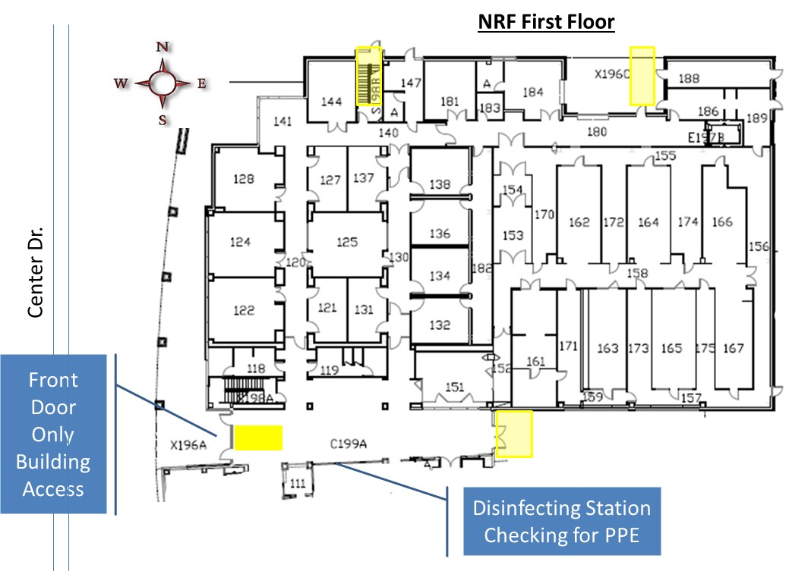
NRF building four access entrances. Disinfection station location.
  - Hand sanitizer and gloves will be available at the front entrance for disinfection and protection.
  - Use the wipes from the roll and 70/30 IPA solution to clean all surfaces of all materials entering the building. This includes samples, carrier boxes, pens, eyeglasses, cell phone or anything in your pockets such keys you may need to remove or touch while in the building.
  - Place a marker on the “RSC Tracker Map Board” in the lobby to indicate where in the building you will be located. If entering the cleanroom, tool specific location is not needed.
  - If you are working with any tool outside the cleanroom you must check out of each space with staff. If during your visit you use more than one tool or lab, you must call staff as you switch rooms to ensure the next room is clean and have your marker position changed on the map. This will allow everyone to know which rooms are occupied and need to be disinfected.

- Protocols for Building Movement/Traffic
  - Hallways are all one-way only loops around the labs so social distancing may easily be observed. Follow the yellow tape direction arrows on the floor.
  - Stairwells are also one-way. The west stairwell near the lobby is for traveling UP and the north stairwell is for DOWN. You should not be able to see anyone in the stairwell prior to using it.
  - Restrooms will be single occupancy. Please change the occupancy sign as you enter and leave the restroom.
  - Elevators will be single occupancy. Hold the door open for at least one minute after use for air exchange.
  - Rooms 141 and 281 will be restricted to one-person occupancy. Refer to the two maps below for these locations. The 2nd floor office area is restricted.

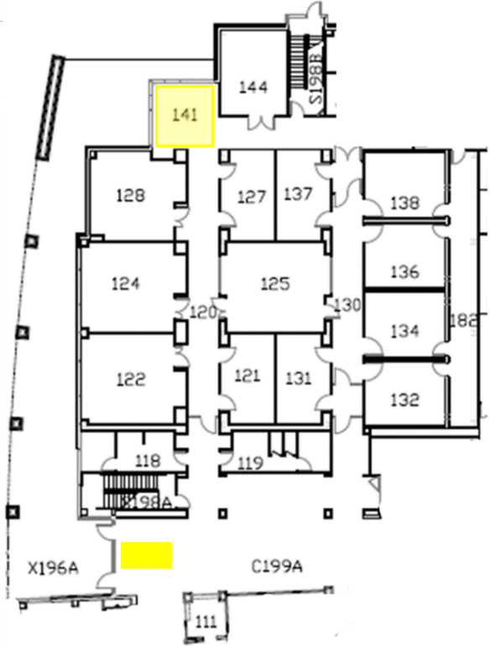
First Floor Common Areas
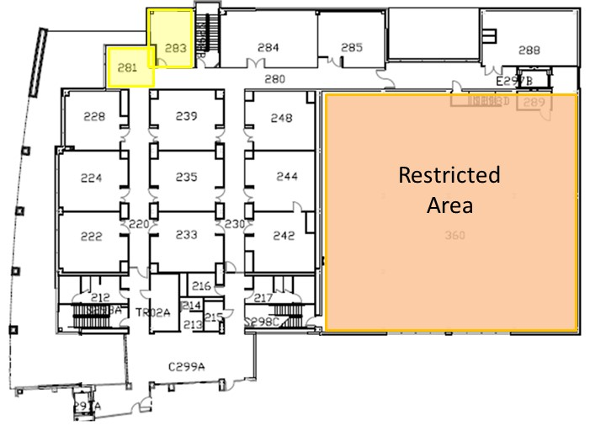
Second Floor Common Areas

- Lab Procedure
  - RSC staff will be monitoring and disinfecting laboratory touch surfaces (keyboards, mice, handles,..) after each user’s session.
  - A CDC/EPA/FDA recommended disinfectant will be located in each user lab. Proper procedures will be provided.
  - Occupancy limited to UF guidelines per building entry RSC Tracker Map Board.
  - When you enter the lab wash your hands. Use of gloves is encouraged to avoid cross contamination when needed.
  - Face coverings must be worn inside the building at all times.
  - If a second person (RSC staff member) is required for temporary assistance, masks and social distance protocol will be followed. If you need staff support, they should be contacted by cell phone.

- Reservations and TUMI Procedure
  - All tools that accept reservations must be reserved prior to use and before submission of the Daily Work Plan.
  - For all tools outside the cleanroom, staff must be contacted immediately when you log off a tool. This is so that staff may clean the workspace after each use. This does not apply to tools inside the cleanroom.

- Cleanroom Procedure
  - Notify staff before your 1st cleanroom entry. Staff will assign a hanger and provide a mesh bag, safety glasses and gown for you.
  - Put on hairnet, blue booties, and beard cover if needed.
  - Only three people are allowed in the cleanroom gowning room at a time (room 151).
  - Put on your cleanroom garments. You must wear your personal mask underneath your veil.
  - Change gloves with standard cleanroom gloves.
  - Occupancy limits per bay are marked at the entry of each bay.
  - Cleanroom personnel will maintain 6 ft minimum social distancing while inside the cleanroom and the personal mask and veil will be kept up over nose.
  - When leaving the cleanroom with the intention of returning that day, place the gown, hood, and veil in the mesh bag and hang on your assigned hanger. When leaving for the day, hang your gown, hood, and veil in the sanitation closet.
  - Gloves will remain on until outside the gown room.

- Building Exit Procedure
  - Check out with staff at the reception desk when leaving the building.
  - Remove your marker from the “RSC Tracker Map Board” and finalize your “Daily Work Plan Form” by marking all areas visited during your visit on the back on the form. This data will be supplied to the “Track and Trace” program when requested.

A safety acknowledgement form must be submitted to the RSC to reinstate the user safety training.
Form can be found at: https://rsc.aux.eng.ufl.edu/_files/documents/3366.docx

General COVID 19 Guidelines for the NFMCF facility:

- FOBs will be used to enter the NFMCF.
- Face coverings must be worn inside the NFMCF at all times.
- Hand sanitizing is required as you enter and leave the facility.
- Use of gloves is encouraged to avoid cross contamination where needed.
- All meetings must occur virtually (e.g. via Zoom).
- Social distancing of at least 6 feet must be maintained both inside and outside of buildings.
- Anyone who has a fever or thinks that he/she might be ill may not enter the facility. If symptoms develop while in the facility, the individual must leave the facility immediately and arrange for testing through the UF Health Test and Trace initiative.
- Only authorized users are allowed in the NFMCF.
- Visitors, vested researchers, or observers are not allowed in the NFMCF facilities until further notice.
- The accompanying of authorized users to assist/observe other authorized users is not allowed under Stages 1 through 3 occupancy restrictions.
- Characterization of radioactive specimens is not allowed until further notice.
- Violations to the safety protocols can result in suspension of access to the facilities.

Sample Drop Off and Pick Up
All sample drop offs and pick-ups for specimens intended for the NFMCF instrumentation must occur at the NRF building using the procedure specified in Section 1 of the RSC Facilities - COVID-19 Related SOP; specimen drop offs and pick ups may not take place at the NFMCF.

Building Entry Procedure
Initially, only experienced and independent NFMCF users will be approved for access, as the anticipation is that the user will require no interaction with staff other than the building entry/exit steps in order to complete their work.
  - Instrument reservation will be required for before submitting the Daily Work Plan.
  - Each visit to the NFMCF will require a work plan to be submitted no later than 3 PM on the business day prior to the use. The “Daily Work Plan Form” is located on the “Policies and Forms” page on the RSC website. It must be filled out completely and submitted to RSC-DWP@ad.ufl.edu.
  - The work plan will be reviewed by staff at a daily meeting and notice of approval supplied to the user the night before the day of work. A time for entry will be confirmed.
  - You must notify RSC staff when you enter the facility.
  - Staff will place a marker on the “RSC Tracker Map Board” in the lobby to indicate your presence in the NFMCF.
  - Only essential items needed for approved work will be allowed inside the facility. Personal belongings cannot be brought outside of the “safe zone” (designated by the striped black and yellow tape) and into the working area. Storage lockers will not be available until further notice.
  - Face coverings must be worn inside the facility at all times.
  - Hand sanitizer and gloves will be available at the facility entrance for disinfection and protection.
  - Use the wipes from the roll and 70/30 IPA solution to clean all surfaces of all materials entering the building. This includes samples, carrier boxes, pens, eyeglasses, cell phone or anything in your pockets such keys you may need to remove or touch while in the building.

Protocols for Building Movement/Traffic
  - Access is restricted to rooms with operational instruments.
  - The NFMCF is restricted to one-person occupancy; no other special protocols for facility movement/traffic are otherwise necessary

Lab Procedure
  - Entry to the facility is only allowed for instrument operation; entry to the facility is not allowed for use of any other instrumentation in the facility (radiation detection devices, micromanipulators, etc.).
  - Only one person is allowed at a time in the NFMCF.
  - When you enter the NFMCF, sanitize your hands. Use of gloves is encouraged to avoid cross contamination when needed.
  - Face coverings must be worn inside the facility at all times.
  - If an RSC staff member is required for temporary assistance, masks and social distance protocol will be followed. If you need staff support, he/she should be contacted by cell phone.

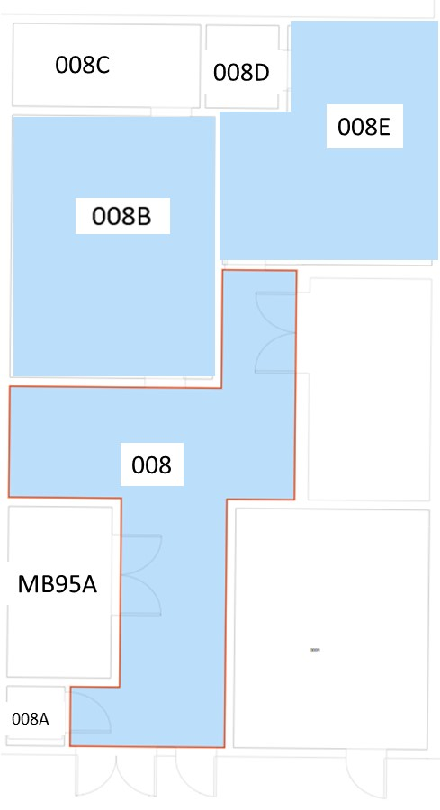
Nuclear and Fuels Materials Characterization Facility

Reservations and TUMI Procedure
  - Instruments must be reserved prior to use and before submission of the Daily Work Plan.
  - Staff must be contacted immediately when you log off the instrument. This is so that staff may clean the workspace after each use.

Building Exit Procedure
  - Contact staff when leaving the facility.
  - Staff will remove your marker from the “RSC Tracker Map Board” and finalize your “Daily Work Plan Form” by marking your visit to the NFMCF on the back on the form. This data will be supplied to the “Track and Trace” program when requested.

A safety acknowledgement form must be submitted to the RSC to reinstate the user safety training.
Form can be found at: https://rsc.aux.eng.ufl.edu/_files/documents/3366.docx

